

**KMU Communication including Notifications via Web Service to iOS**

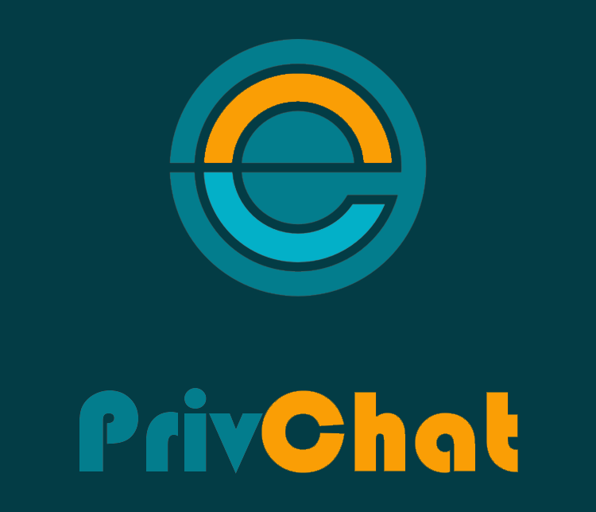

Project Work 1

Jorge Hernández Gómez

June 2015

1. Project plans

* 1. Project assignment

Objectives

* Develop a chat application for IOS
* Enable group chat
* Enable Push notifications
* Configure a server for the chat

Phases

* Interface Design, Mockups
* Research for chat implementation, push notifications and programming language to use
* Configuration of frameworks and external tools needed
* Implementation
* Debugging and testing

Project team

* Jorge Hernandez Gomez (developer, interface designer, debugger)

Optional resources required

* Computer with Mac OS X installed to develop for iOS
* Iphone for testing in a real device
* Apple Developer Account to allow push notifications
  1. Aims
* Develop a real-time chat application for iOS devices
* Enable push notifications
* Secure connection to server
* Affordable and easy solution for small and medium enterprises
  1. Work Breakdown Structure (WBS)

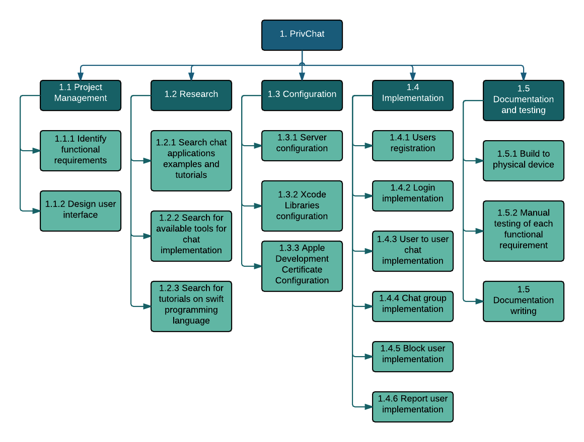

* 1. Work package specifications

|  |  |
| --- | --- |
| WP | 1.1.1 Identify functional requirements |
| Objective | Analyze the functions that are necessary for the application to meet the project goals |
| Non-objective | Look for future updates |
| Result | A list of functional requirements can be seen in the project’s repository documentation directory |

|  |  |
| --- | --- |
| WP | 1.1.2 Design user interface |
| Objective | Create mockups that help creating the user interface for the application |
| Non-objective | Interaction between the mockups is not expected |
| Result | An arrange of the prototypes used can be seen in the project’s repository documentation directory |

|  |  |
| --- | --- |
| WP | 1.2.1 Search chat applications examples and tutorials for iOS |
| Objective | Get knowledge on how to implement a chat client application in iOS |
| Non-objective | Make research on other platforms |
| Result | A list of resources can be seen in the project’s repository documentation directory |

|  |  |
| --- | --- |
| WP | 1.2.2 Search for available tools for chat server implementation |
| Objective | Make a comparison of the different available tools for creating a chat server |
| Non-objective | Finding tutorials to create a chat server from zero |
| Result | A list of sources can be seen in the project’s repository documentation directory |

|  |  |
| --- | --- |
| WP | 1.2.3 Search for tutorials on swift programming language |
| Objective | Gain basic and fundamental knowledge about the new Apple’s programming language |
| Non-objective | Get into all technical background of the language |
| Result | A list of helpful sources can be seen in the project’s repository documentation directory |

|  |  |
| --- | --- |
| WP | 1.3.1 Server configuration (Parse) |
| Objective | Create a new account for a parse server, database models and enable push notifications |
| Non-objective | Add unnecessary extra-features provided by the service |
| Result | A fully operational server that can communicate with the iOS client app, create and retrieve data. |

|  |  |
| --- | --- |
| WP | 1.3.2 Xcode libraries configuration |
| Objective | Add necessary libraries to Xcode so it can use the Parse server |
| Non-objective | Add unnecessary extra libraries |
| Result | The app can now communicate with Parse and all SDK functions can be used in the project. More detail about the libraries needed can be seen in the project’s repository readme |

|  |  |
| --- | --- |
| WP | 1.3.3 Apple development certificate configuration |
| Objective | Create a certificate for iOS apps development in a physical device using a valid Apple Developer Account. |
| Non-objective | Add unnecessary features to the certificate like ads or tracking gaming score |
| Result | The app can now be tested in a physical device along with the push notification feature. The result can be seen in the live demo. |

|  |  |
| --- | --- |
| WP | 1.4.1 Users registration |
| Objective | Upload a new user to the database from the app |
| Non-objective | Add account verification by email |
| Result | A new user can be successfully registered from the app and it is stored in the database |

|  |  |
| --- | --- |
| WP | 1.4.2 Login implementation |
| Objective | Allow a registered user to login to the application |
| Non-objective | Social media login (Facebook login) |
| Result | A registered user can successfully login from the app. |

|  |  |
| --- | --- |
| WP | 1.4.3 User to user chat implementation |
| Objective | Create the view and functionality for a chat between 2 persons |
| Non-objective | Create a “seen” feature for the messages |
| Result | Users can chat between each others in the app, each message is successfully uploaded and retrieved from the server and they are notified in case a new message is sent |

|  |  |
| --- | --- |
| WP | 1.4.4 Chat group implementation |
| Objective | Create a chat room between different users in the app |
| Non-objective | Have admin capabilities within a group for banning users or reporting them |
| Result | A new chat group can be created an everyone that participates in it receives a notification when a new message is sent. |

|  |  |
| --- | --- |
| WP | 1.4.5 Block user implementation (in user to user chat) |
| Objective | Be able to block a user for sending messages in a conversation |
| Non-objective | Notify the reasons for the blocking |
| Result | Users can be blocked in a chat conversation |

|  |  |
| --- | --- |
| WP | 1.4.6 Report user implementation |
| Objective | Allow users to report another user for a bad behavior or use of offensive language |
| Non-objective | Notify the reported user about the reasons for the report |
| Result | A user can report another within the chat conversation |

|  |  |
| --- | --- |
| WP | 1.5.1 Build to physical device |
| Objective | Build the application to a physical device to test functionality and push notifications. |
| Non-objective | Testing on simulator only |
| Result | Application successfully built on a physical device. In the live demo could be seen. |

|  |  |
| --- | --- |
| WP | 1.5.2 Manual testing of functional requirements |
| Objective | Test all of the functionality implemented. |
| Non-objective | For time constraints more automated tests couldn’t be implemented |
| Result | All the views were tested and they displayed the desired outputs. |

|  |  |
| --- | --- |
| WP | 1.5.3 Documentation writing |
| Objective | Document the way the project was developed. Code is also documented. |
| Non-objective | Make a full documentation |
| Result | Readme file, project planning document and additional files provided in the project. |

* 1. Milestoneplan

